MEENAKSHI COLLEGE OF ENGINEERING

Name:LOHITHYA L B

Dept:IT

Year:3rd year

Reg no:311420205013

In the last Assignment you have created index.html and profile.html. So, now in this assignment you have create two html pages and style it using css.

1. Login and Register html page

**Task 1**: You need to run the html pages in server by using Flask web framework

**Task 2**: Store the user registration details in IBM DB2

**Task 3**: while user logging in do the login validation (checking the login credentials is correct or not)

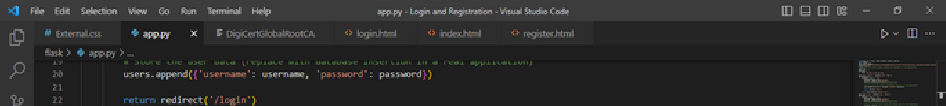**App.py:**

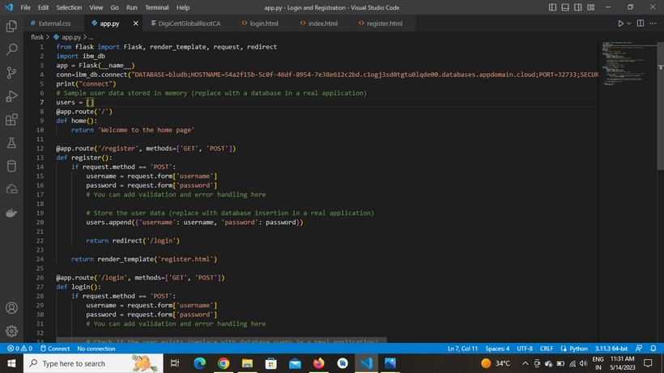

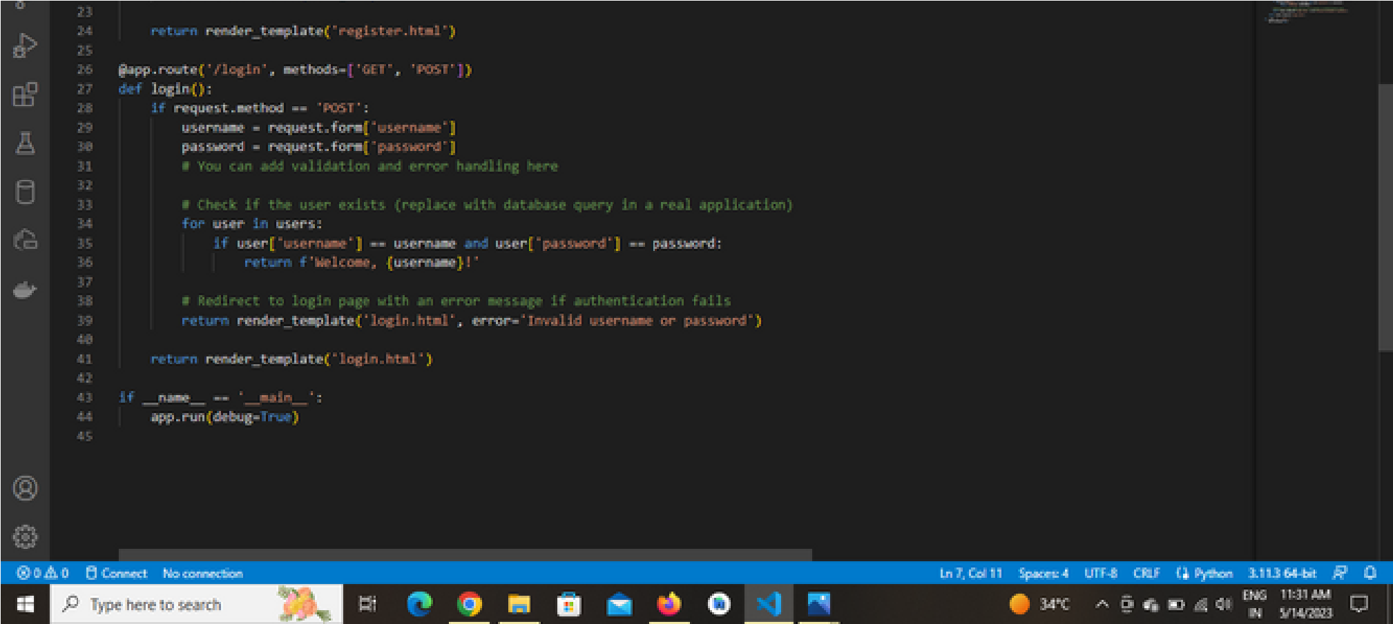

**External.css**

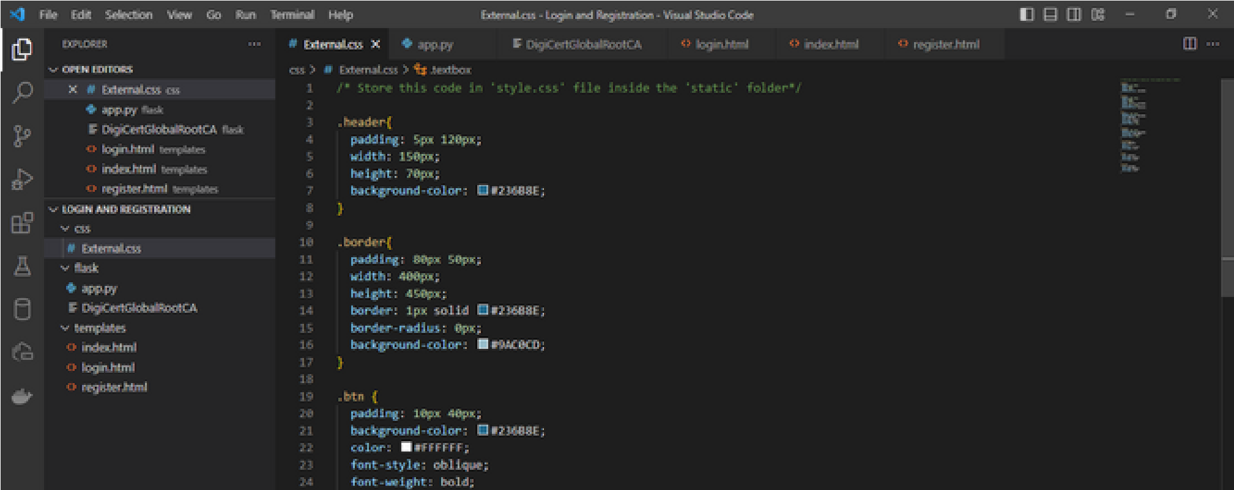

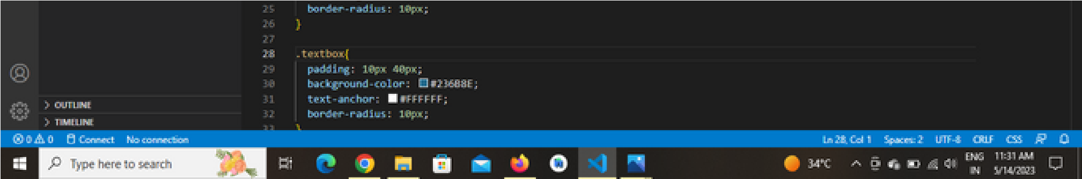

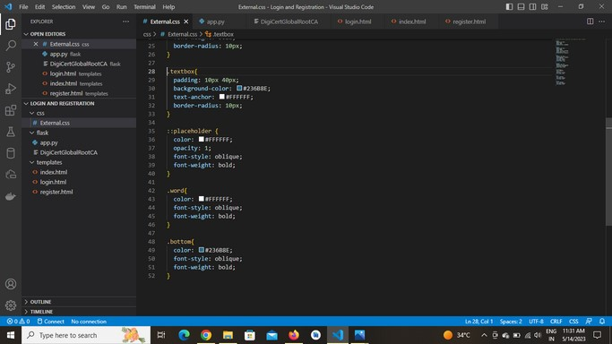

**Index.html**

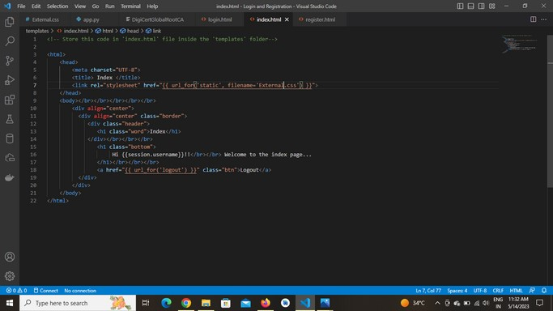

**Login.html**

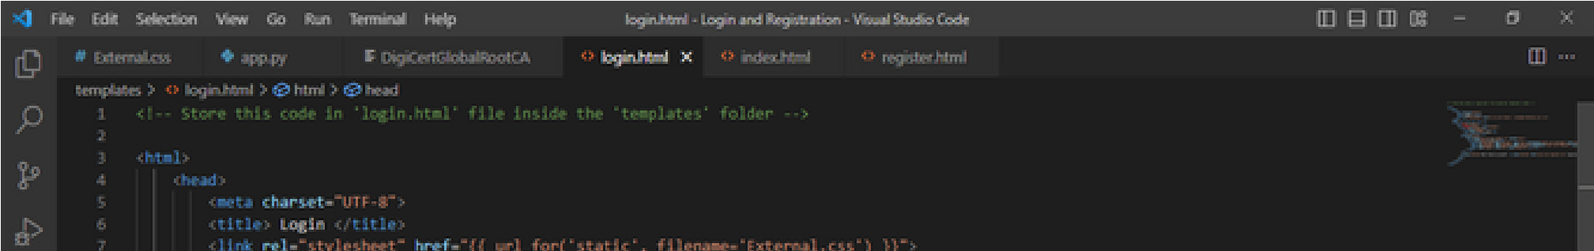

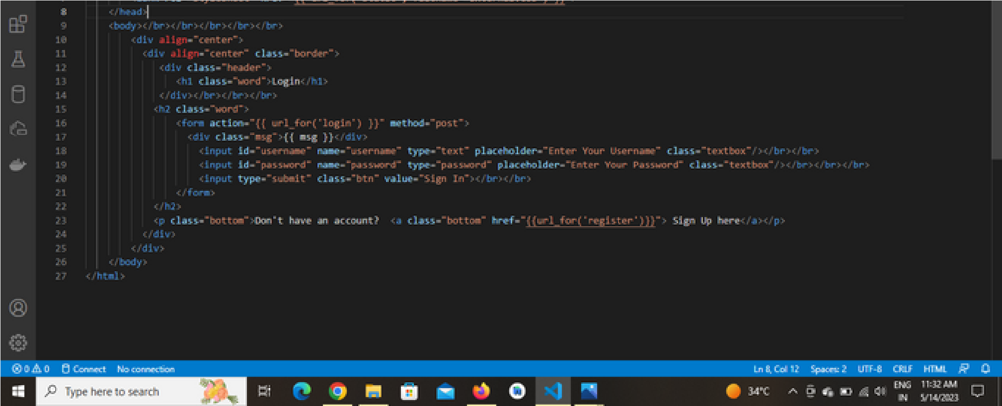

**Register.html**

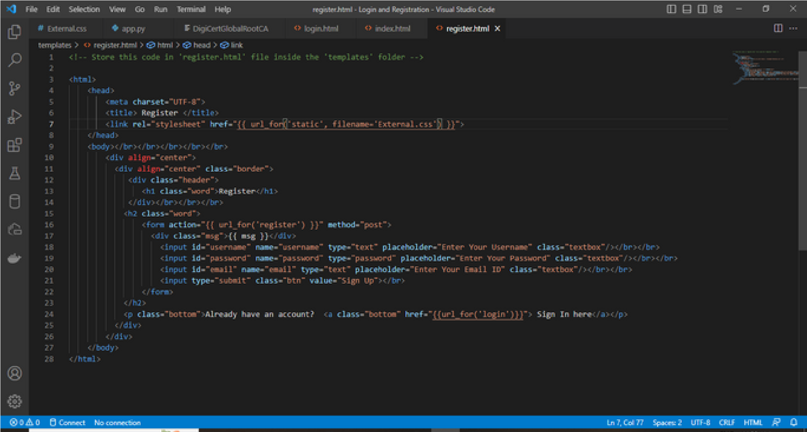

Login page:

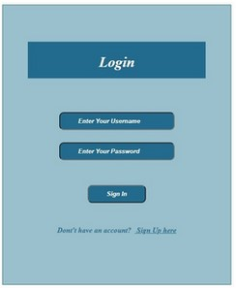

Registration page:

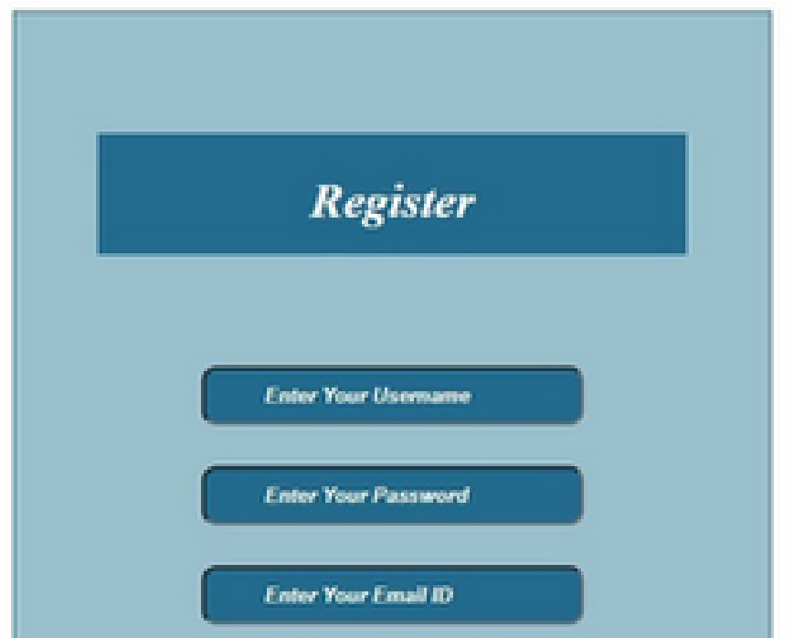



If registration successful:



Database Table:

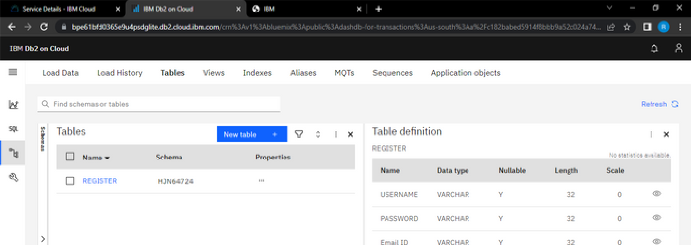

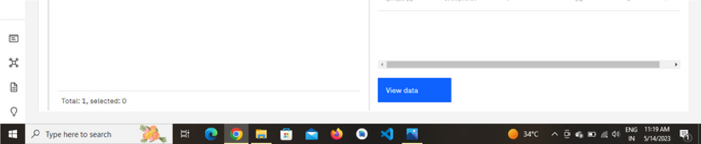

If login successful:

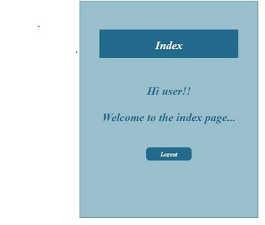

Index page is displayed:

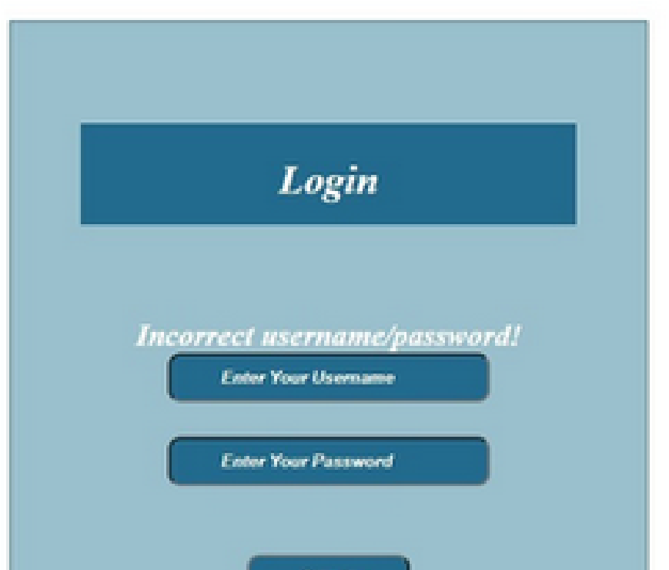



1.